S06-Transcriptions
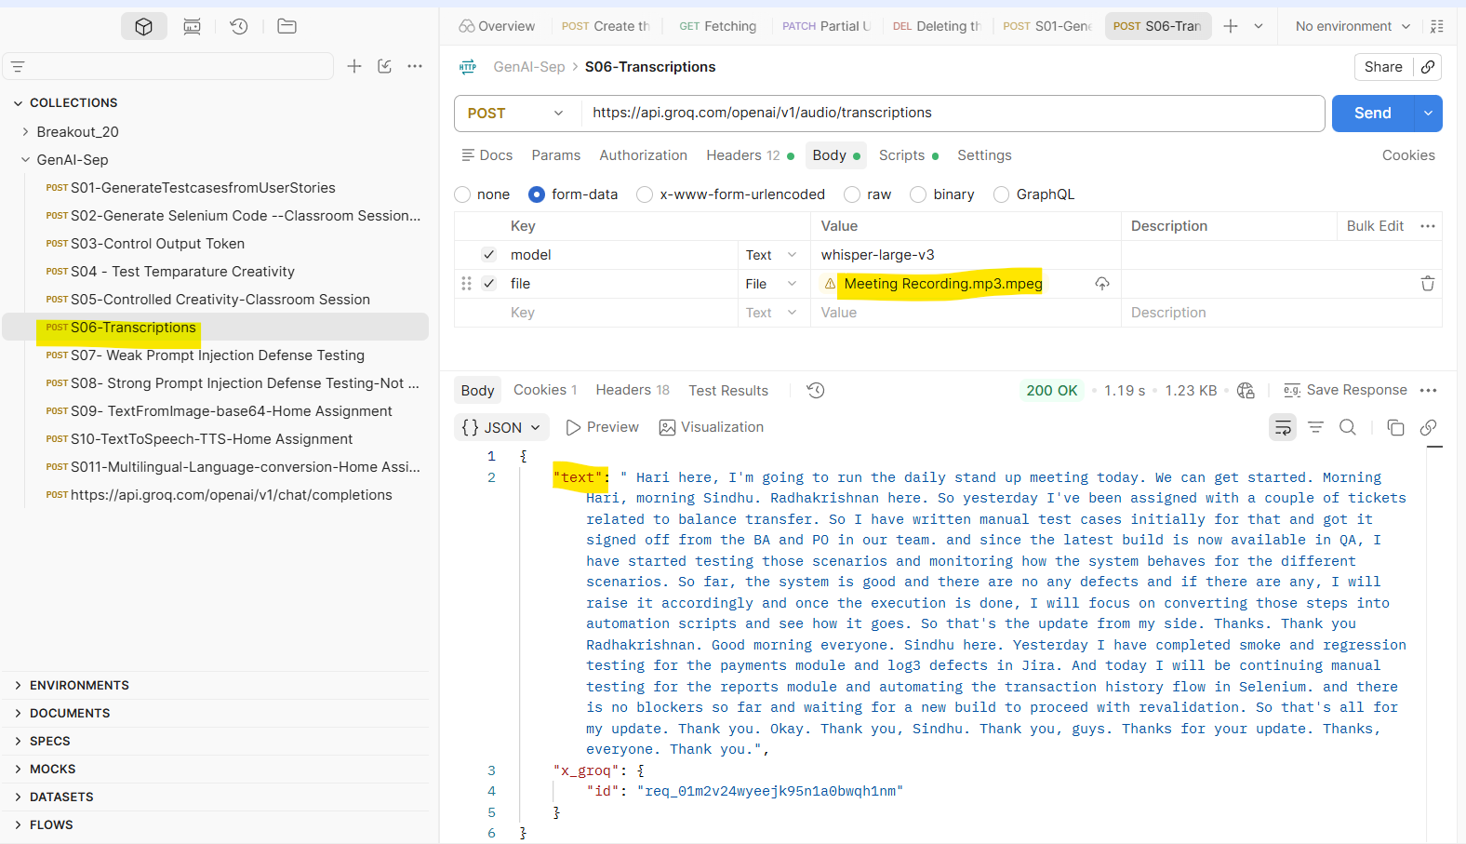
Output:
{
"text": " Hari here, I'm going to run the daily stand up meeting today. We can get started. Morning Hari, morning Sindhu. Radhakrishnan here. So yesterday I've been assigned with a couple of tickets related to balance transfer. So I have written manual test cases initially for that and got it signed off from the BA and PO in our team. and since the latest build is now available in QA, I have started testing those scenarios and monitoring how the system behaves for the different scenarios. So far, the system is good and there are no any defects and if there are any, I will raise it accordingly and once the execution is done, I will focus on converting those steps into automation scripts and see how it goes. So that's the update from my side. Thanks. Thank you Radhakrishnan. Good morning everyone. Sindhu here. Yesterday I have completed smoke and regression testing for the payments module and log3 defects in Jira. And today I will be continuing manual testing for the reports module and automating the transaction history flow in Selenium. and there is no blockers so far and waiting for a new build to proceed with revalidation. So that's all for my update. Thank you. Okay. Thank you, Sindhu. Thank you, guys. Thanks for your update. Thanks, everyone. Thank you.",
"x_groq": {
"id": "req_01m2v24wyeejk95n1a0bwqh1nm"
}
}

